Tasks:-
•1. Look at the man page of “ps” and search for “STANDARD FORMAT SPECIFIERS” run the following
command.
ps -o pid,ppid,cmd -u your_user_id
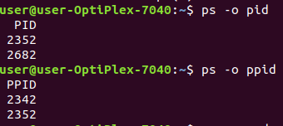

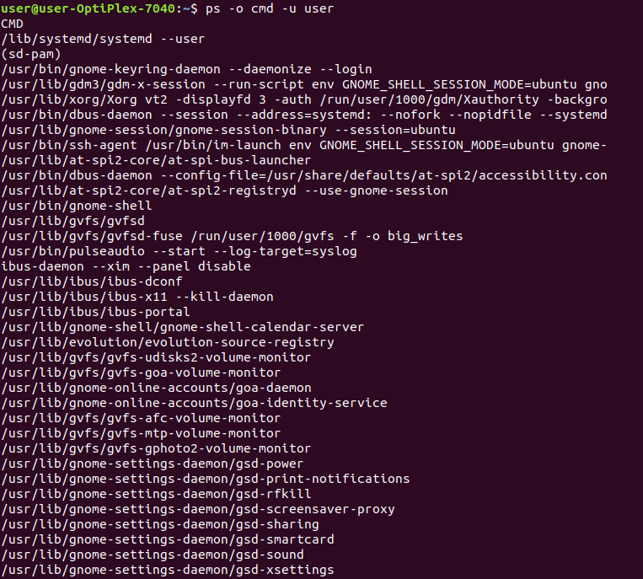
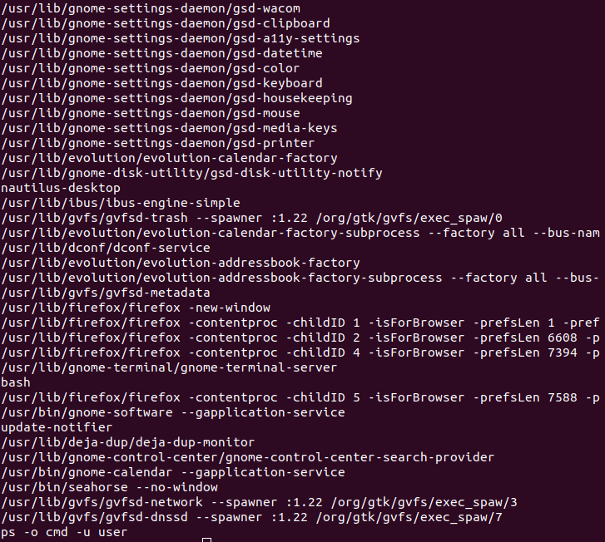
2. What are the last three lines of output? now run the same command by adding the -H option.
ps -H -o pid,ppid,cmd -u your_user_id
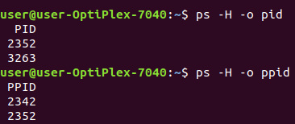

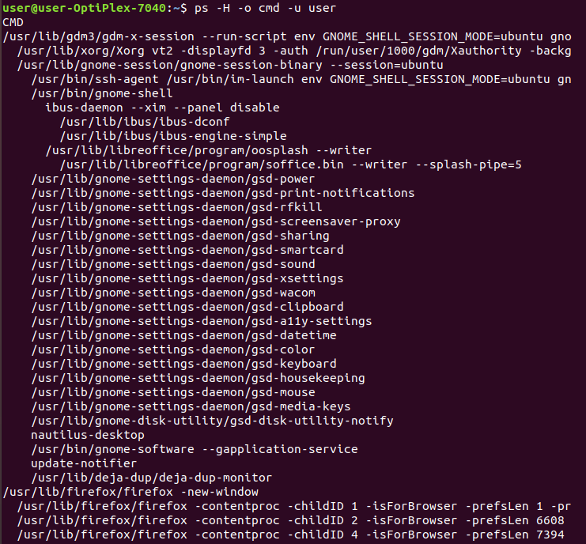
3. How would you use the tail command in a pipe to obtain the last six lines of output from the “ps -A” command?
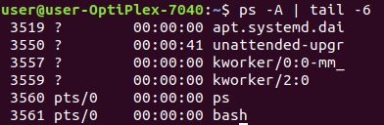

4. Which pipe of commands would you use to count the number of processes owned by you only?
Run the command and count how many processes you own?
